**Supermarket Management System**



**Session: 2022 – 2026**

**Submitted by:**

Rida Batool

2022-CS-118

**Supervised by:**

Sir Awais

Department of Computer Science

**University of Engineering and Technology**

**Lahore Pakistan**

**Contents**

**Short Description of Project:** 4

**Users of Application:** 4

**Customers** 4

**Admins:** 4

**Functional Requirements:** 4

**Wireframes:** 5

**OOP Concepts:** 10

**Association** 10

**Inheritance** 10

**Encapsulation:** 10

**Design Pattern Implementation:** 11

**Class Details:** 11

**Class Diagram:** 11

**Code:** 12

**Business Layer:** 12

**TheUser Class:** 12

**Admin Class:** 13

**Customer Class:** 13

**Product Class:** 14

**Data Layer:** 18

**TheUserDL:** 18

**CustomerDL:** 20

**ProductDL:** 23

**Forms:** 26

**Form1:** 26

**SignUp Form:** 28

**SignIn Form:** 30

**Admin Forms:** 32

**AdminMenu Form:** 32

**ListProduct Form:** 35

**AddProduct Form:** 36

**DeleteProduct Form:** 37

**UpdateProduct Form:** 39

**UpdateProductForm Form:** 40

**TaxCalculation Form:** 41

**ViewOrders Form:** 42

**Customer Forms:** 43

**CustomerMenus Form:** 43

**ProductList Form:** 45

**MakeOrder Form:** 46

**OrderingForm Form:** 47

**ViewCart Form:** 49

**GetBill Form:** 50

**GiveFeedBack Form:** 51

**Conclusion:** 52

**Supermarket Management System**

# **YouTube Video Link:**

* <https://www.youtube.com/watch?v=C7R6Cc2yl9U>

# **Short Description of Project:**

The Supermarket Centralized Management System is a software solution designed to automate and streamline the sales and inventory management processes in a supermarket. The system centralizes all information related to products, managers, customers, billing, and other aspects of the business, making it easier for the business owner to keep track of sales on a daily basis.

The manual process of recording sales and maintaining records is time-consuming and prone to errors, but the Supermarket Centralized System Management eliminates these issues by providing fast and accurate calculation and information management. The system ensures that sales activity is completed quickly and efficiently, reducing the workload and freeing up time for other tasks. Overall, the Supermarket Centralized System Management is an efficient and effective solution for managing the day-to-day operations of a supermarket.

# **Users of Application:**

The users of the application will be admin, employees and customers.

**Customers:** Customers who will purchase or use the product. There can be a number of customers being facilitated by the services.

**Admins:** An administrator who oversees the centralized management system for a supermarket, responsible for controlling customer and employee access and actions, and ensuring the delivery of excellent services to customers for their satisfaction.

# **Functional Requirements:**

|  |  |  |  |
| --- | --- | --- | --- |
| **User Story Id** | **As** | **I can perform** | **So that I can** |
| 1. | Admin | * LogIn. * Add or Delete Products. * Modification in Rate of Products. * Keep an eye on what Customers do. * View Orders. * Calculate Tax * LogOut. | * Manage the System properly. |
| 2. | Customers | * LogIn. * View List of Products. * Make Order * View Cart * Get Bill * Give Feedback * LogOut. | * Buy Products. * Use Products. |

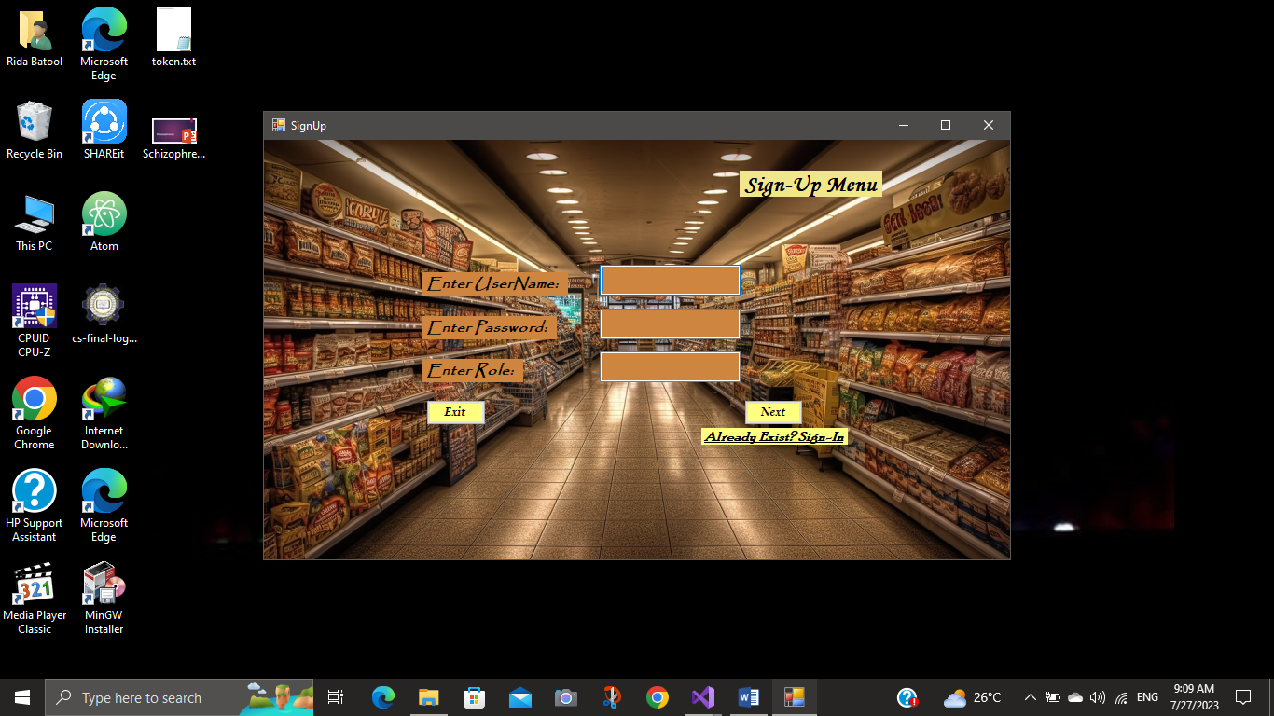

# **Wireframes:**

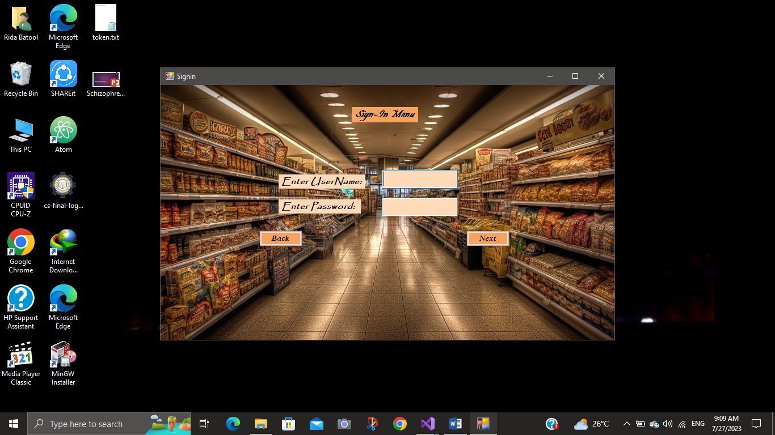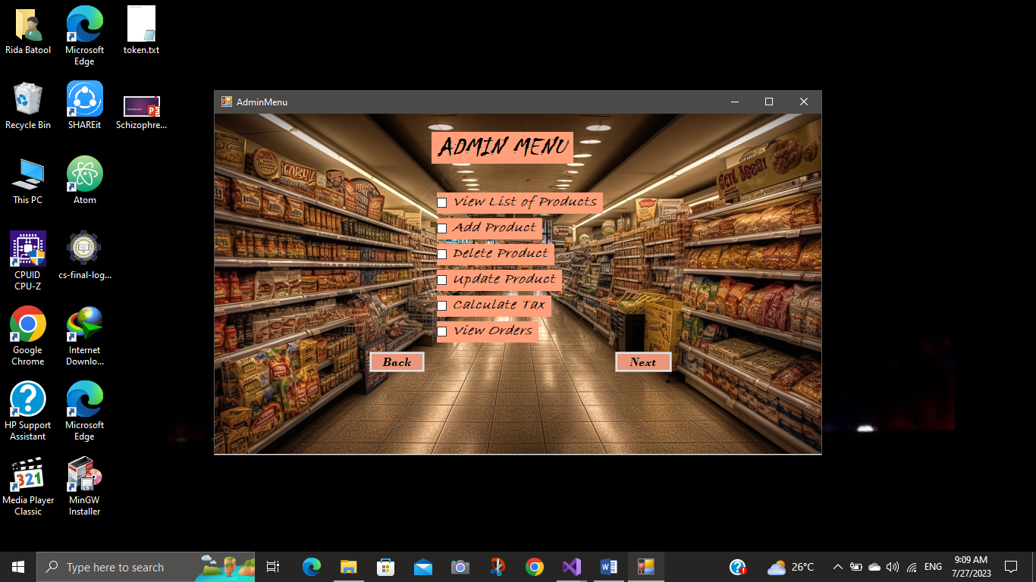

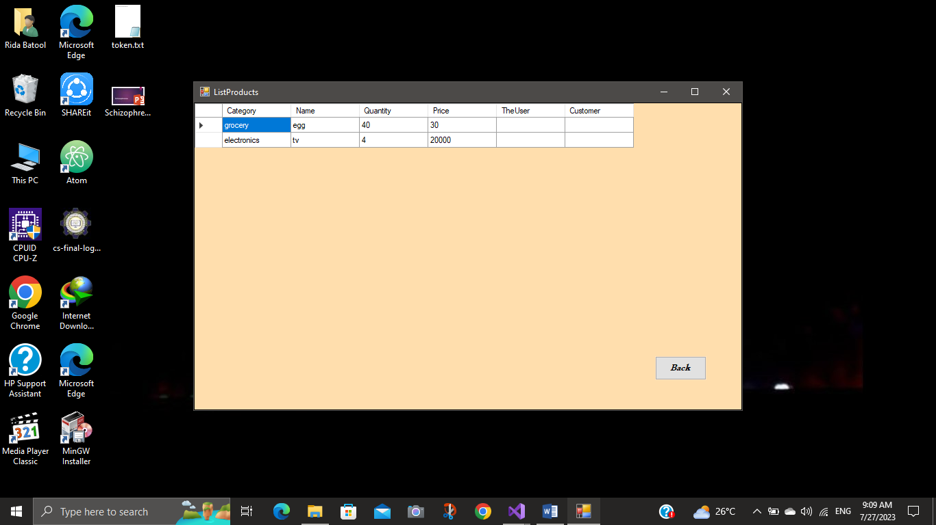

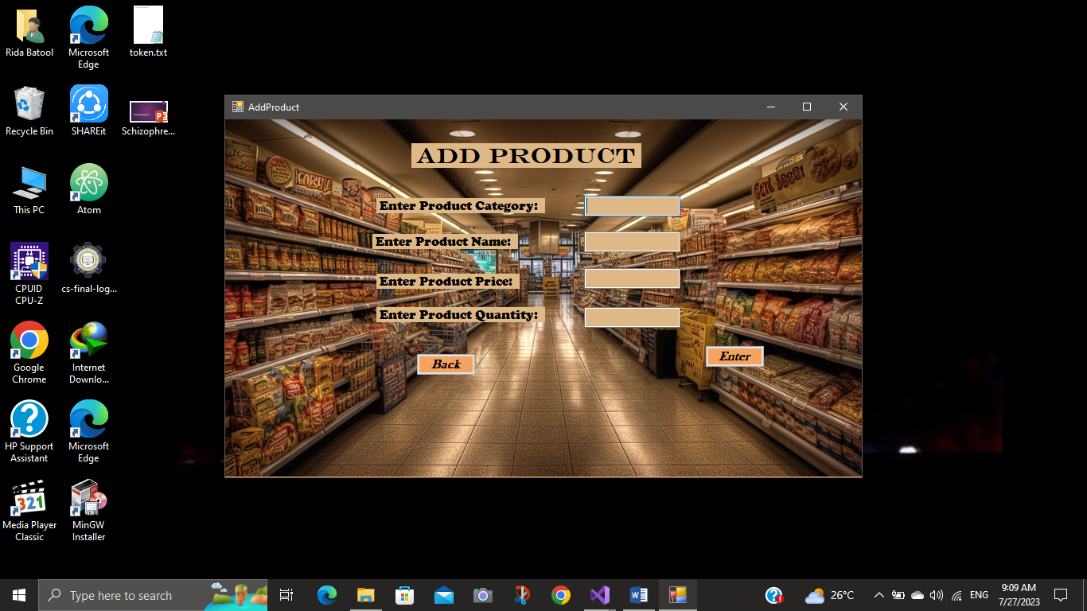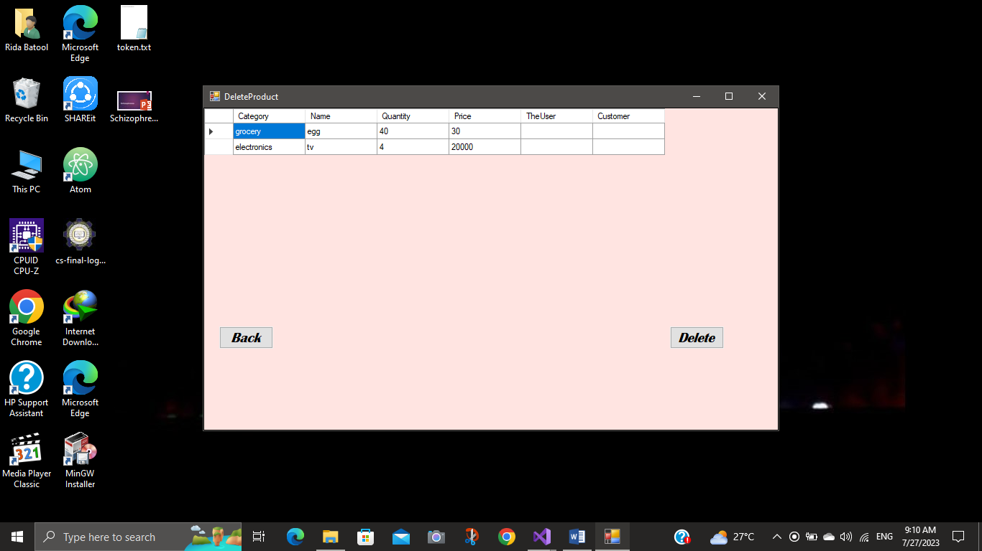

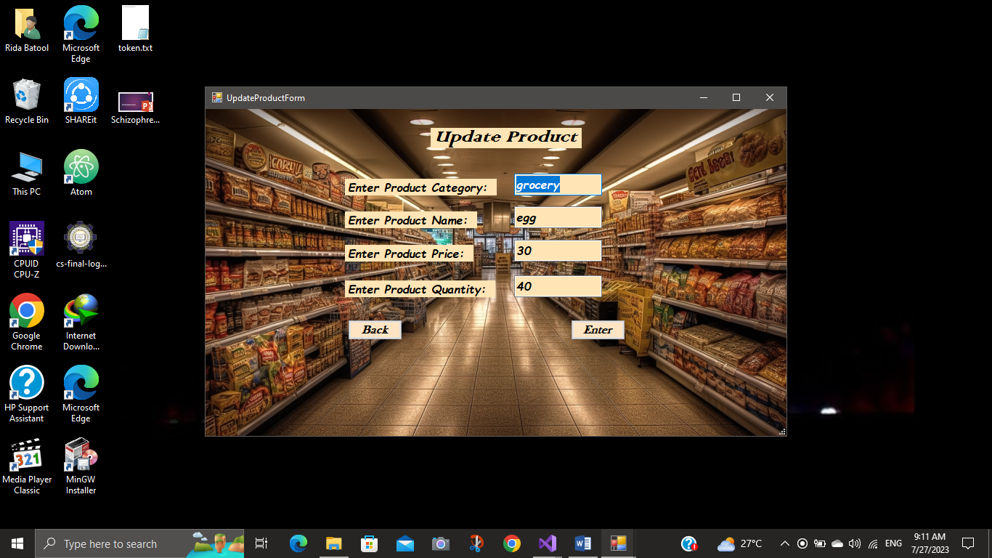

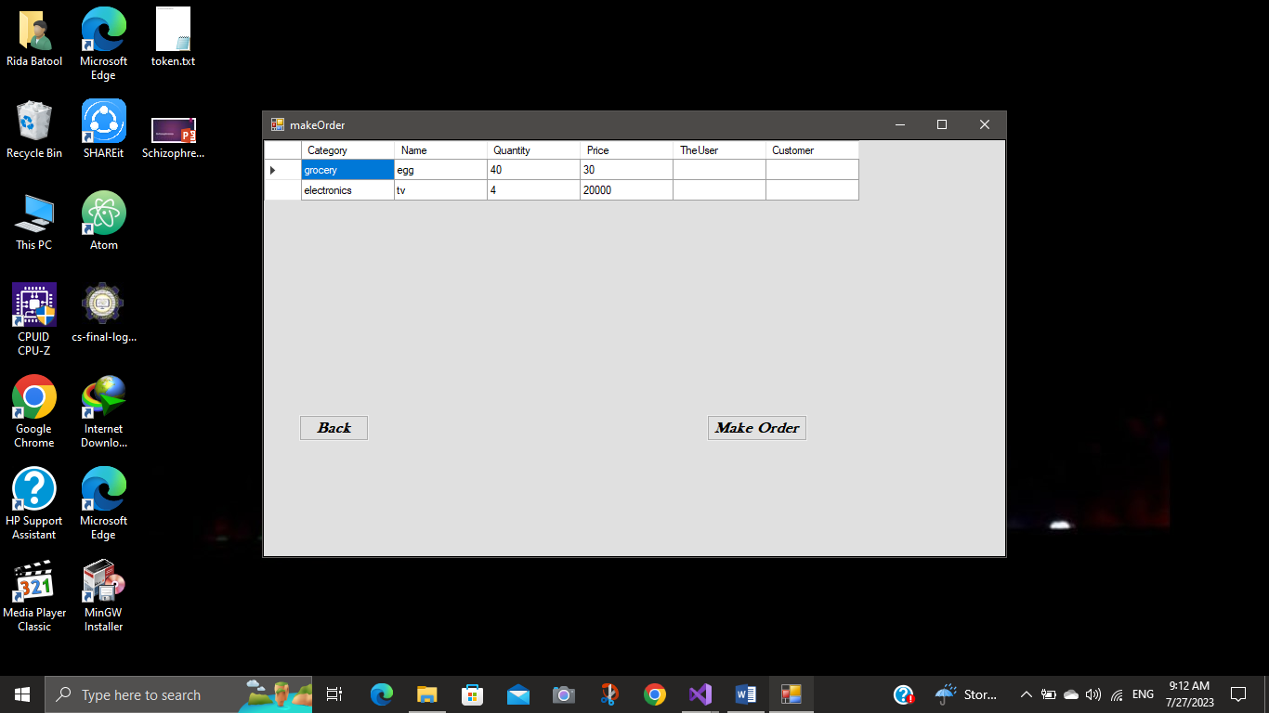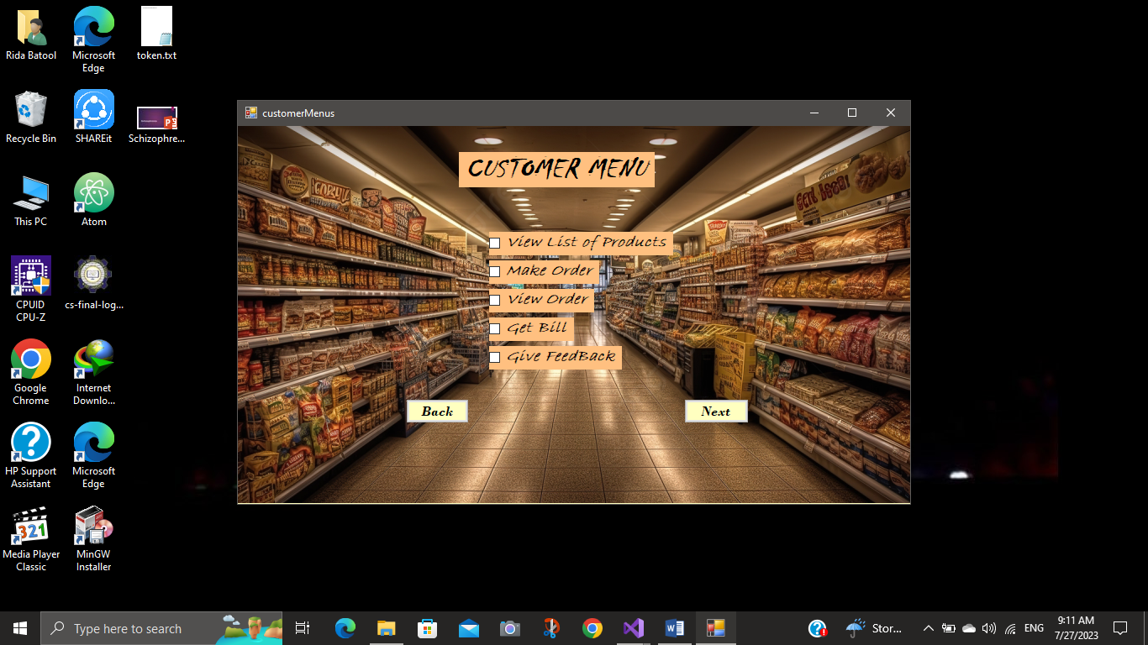

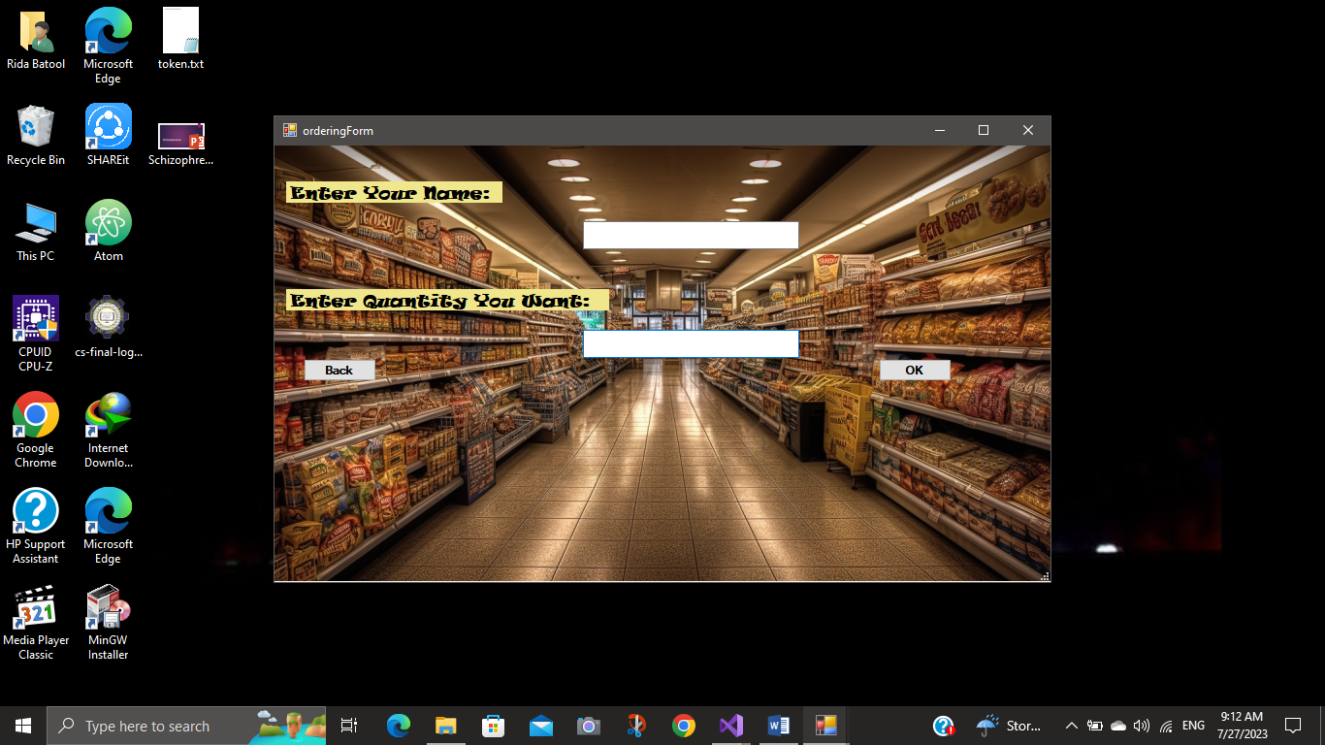

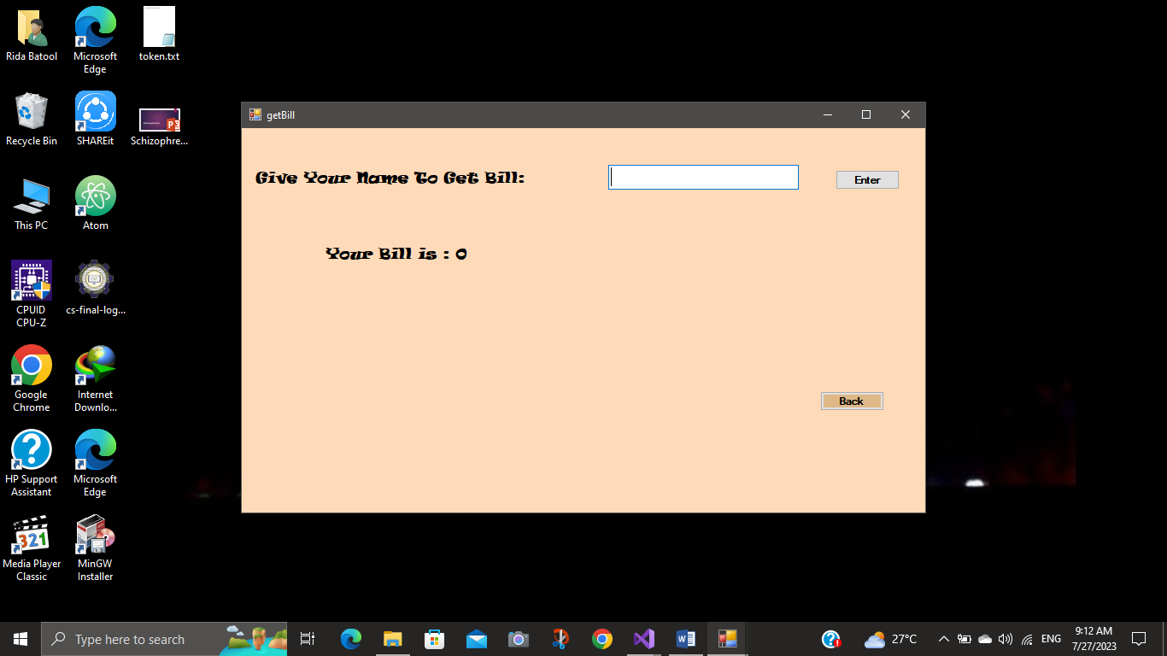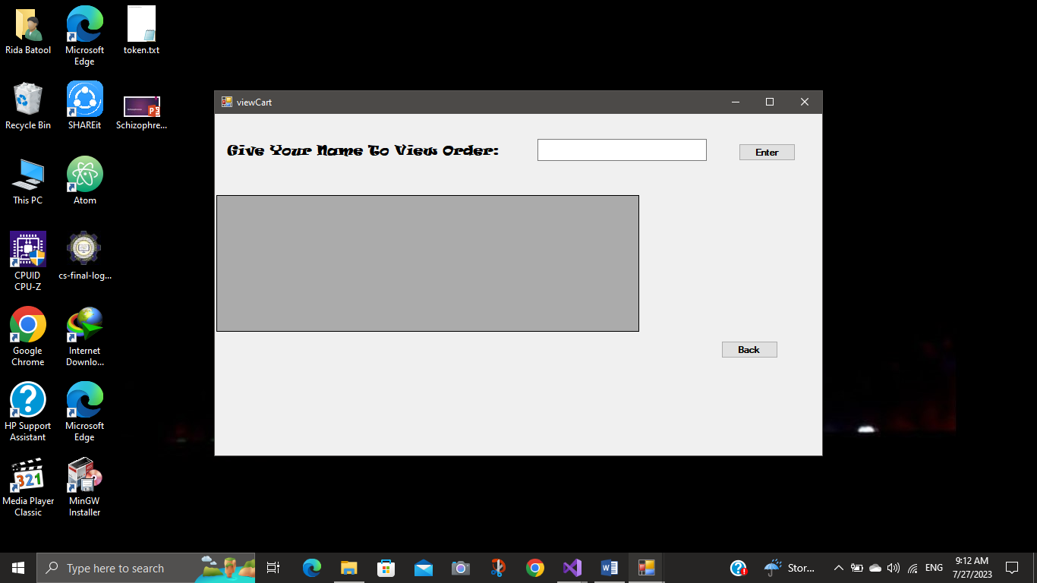

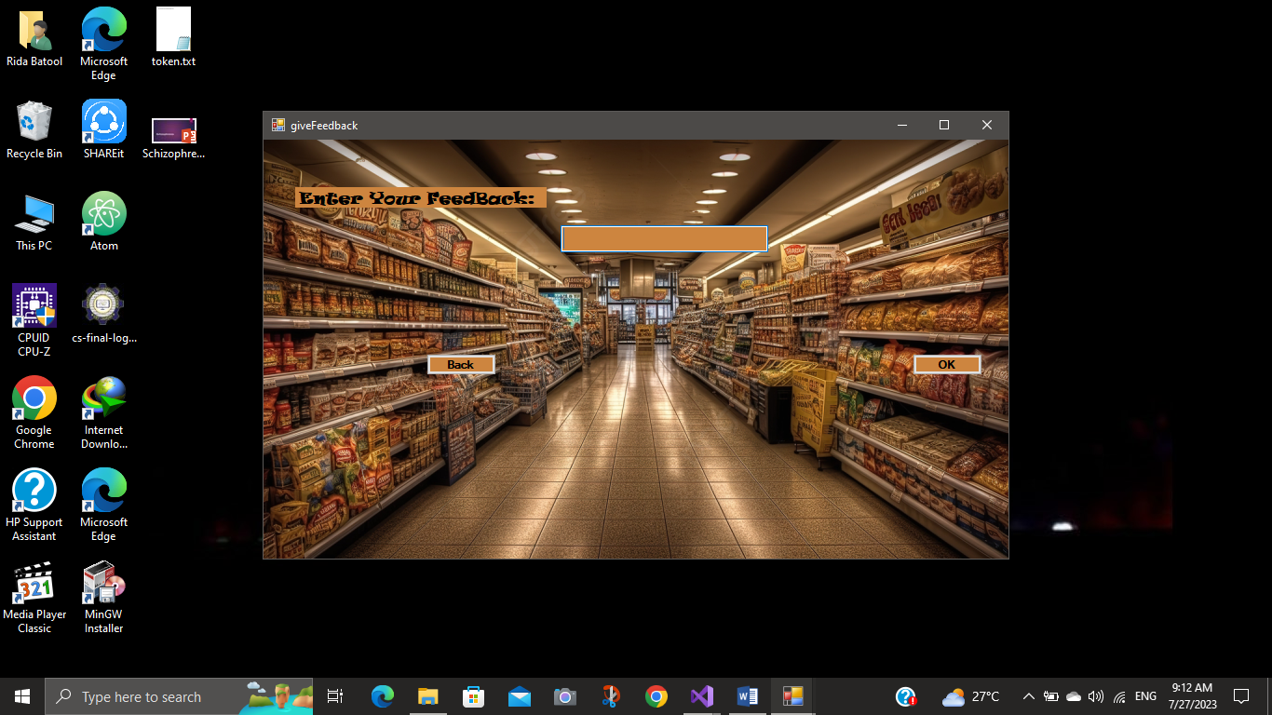

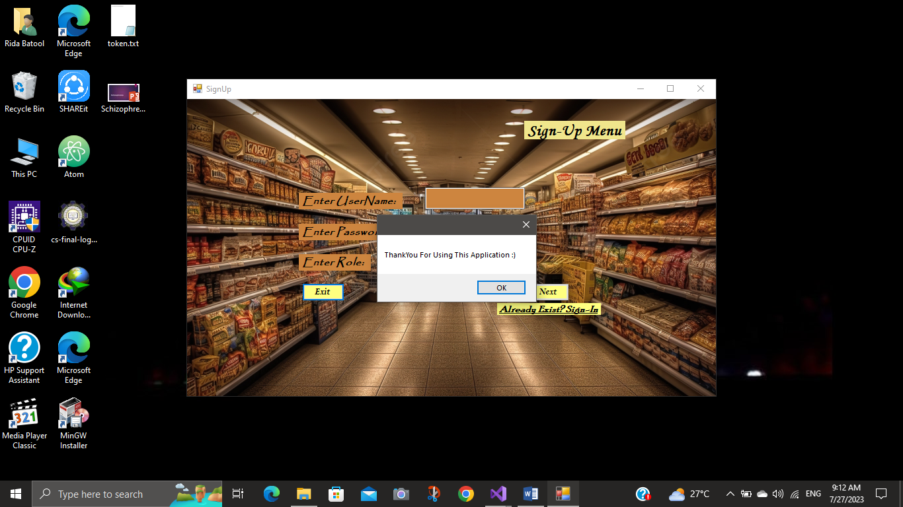

# **OOP Concepts:**

**Association:**

The type of association my project contain is aggregation.

The class Product class is aggregated with TheUser Class. There is aslo an aggregated association between Product and Customer classes.

Customer class contain a list of bought products of Product type.

**Inheritance:**

The parent class TheUser inherits two classes Admin and Customer.

Admin and Customer are the child classes. Child classes can access the attributes of its parent class as its own.

## **Encapsulation:**

All the attributes of each class is encapsulated as private.

These can be accessed using getter and setter functions.

All the attributes of TheUser Class are protected and they can only be accessed by its Child classes.

# **Design Pattern Implementation:**

Three tier Model is implemented; separate Business layer, data layer, User interface.

This allows us to define functions separately and we just then need to call these functions in main program.

# **Class Details:**

My project has two main classes; TheUser, Product.

TheUser inherits two more classes; Admin and Customer.

Separate classes for BL, DL, UI are made.

# **Class Diagram:**

# **Code:**

## **Business Layer:**

### **TheUser Class:**

public class TheUser

{

protected string username;

protected string password;

protected string role;

public TheUser(string username, string password)

{

this.username = username;

this.password = password;

}

public TheUser(string username, string password, string role) : this(username, password)

{

this.role = role;

}

public TheUser()

{

}

public void setName(string username)

{

this.username = username;

}

public string getUserName()

{

return this.username;

}

public void setPassword(string password)

{

this.password = password;

}

public string getPassword()

{

return this.password;

}

public void setRole(string role)

{

this.role = role;

}

public string getRole()

{

return this.role;

}

public string toString()

{

return "TheUSer[Role: " + role + ", UserName: " + username + ", Password: " + password + "]";

}

### **Admin Class:**

public class Admin : TheUser

{

public Admin(string username, string password) : base(username, password)

{

this.username = username;

this.password = password;

}

### **Customer Class:**

public class Customer : TheUser

{

private List<Product> buyedProducts = new List<Product>();

private Product p;

public Customer(string username, string password) : base(username, password)

{

this.username = username;

this.password = password;

}

public Customer (string username, List<Product> p)

{

this.username = username;

buyedProducts = p;

}

public Customer(string username, Product p)

{

this.username = username;

this.P = p;

}

public Product P { get => p; set => p = value; }

public List<Product> getBuyedProducts()

{

return buyedProducts;

}

### **Product Class:**

public class Product

{

private string category;

private string name;

private int quantity;

private int price;

public string Category { get => category; set => category = value; }

public string Name { get => name; set => name = value; }

public int Quantity { get => quantity; set => quantity = value; }

public int Price { get => price; set => price = value; }

public TheUser TheUser

{

get => default;

set

{

}

}

public Customer Customer

{

get => default;

set

{

}

}

public Product(string category, string name, int quantity, int price)

{

this.Category = category;

this.Name = name;

this.Quantity = quantity;

this.Price = price;

}

public void setCategory(string category)

{

this.Category = category;

}

public string getcategory()

{

return this.Category;

}

public void setName(string name)

{

this.Name = name;

}

public string getName()

{

return this.Name;

}

public void setQuantity(int quantity)

{

this.Quantity = quantity;

}

public int getQuantity()

{

return this.Quantity;

}

public void setPrice(int price)

{

this.Price = price;

}

public int getPrice()

{

return this.Price;

}

public float calculateTax()

{

float tax = 0;

if (Category == "grocery" || Category == "Grocery")

{

tax = (float) (Price * 0.1);

}

else if (Category == "fruit" || Category == "Fruit")

{

tax = (float)(Price * 0.05);

}

else

{

tax = (float)(Price * 0.15);

}

return tax; }

## **Data Layer:**

### **TheUserDL:**

public class TheUserDL

{

private static List<TheUser> users = new List<TheUser>();

public static TheUser isUserExists(string name)

{

foreach (TheUser s in users)

{

if (s.getUserName() == name)

{

return s;

}

}

return null;

}

public static void addTolist(TheUser user)

{

users.Add(user);

}

public static void addToFile(string path, TheUser user)

{

StreamWriter f = new StreamWriter(path, true);

f.WriteLine(user.getUserName() + "," + user.getPassword() + "," + user.getRole());

f.Flush();

f.Close();

}

public static bool loadFromFile(string path)

{

StreamReader f = new StreamReader(path);

string record;

if (File.Exists(path))

{

while((record = f.ReadLine())!= null)

{

string[] splittedRecord = record.Split(',');

string username = splittedRecord[0];

string password = splittedRecord[1];

string role = splittedRecord[2];

TheUser data = new TheUser(username, password, role);

TheUserDL.addTolist(data);

}

f.Close();

return true;

}

else

{

return false;

}

}

public static TheUser signIn(TheUser d)

{

foreach (TheUser s in users)

{

if (d.getUserName() == s.getUserName() && d.getPassword() == s.getPassword())

{

return s;

}

}

return null;

}

### **CustomerDL:**

public class CustomerDL

{

private static List<Customer> orders = new List<Customer>();

public static void addToList(Customer p)

{

orders.Add(p);

}

public static List<Customer> getOrders()

{

return orders;

}

public static void addToFile(string path, Customer p)

{

StreamWriter f = new StreamWriter(path, true);

f.WriteLine(p.getUserName() + "," + p.P.Category + "," + p.P.Name + "," + p.P.Quantity, p.P.Price);

f.Flush();

f.Close();

}

public static bool readFromFile(string path)

{

StreamReader f = new StreamReader(path);

string record;

if (File.Exists(path))

{

while ((record = f.ReadLine()) != null)

{

string[] splittedRecord = record.Split(',');

string name = splittedRecord[0];

string category = splittedRecord[1];

string pname = (splittedRecord[2]);

int quantity = int.Parse(splittedRecord[3]);

int price = int.Parse(splittedRecord[4]);

Product p = new Product(category, pname, quantity, price);

Customer c = new Customer(name, p);

addToList(c);

}

f.Close();

return true;

}

return false;

}

public static void viewOrders()

{

string products;

foreach(Customer p in orders)

{

products = "";

for(int i = 0; i < p.getBuyedProducts().Count; i++)

{

products = products + p.getBuyedProducts()[i].getName() + "\t" + p.getBuyedProducts()[i].getQuantity() + "\t" + p.getBuyedProducts()[i].getPrice() + "\t";

}

Console.WriteLine(p.getUserName() + "\t" + products);

}

}

public static Customer viewCart(string name)

{

foreach(Customer p in orders)

{

if (p.getUserName() == name)

{

return p;

}

}

return null;

}

public static int getBill(string username)

{

int bill = 0;

foreach(Customer c in orders)

{

if (c.getUserName() == username)

{

for (int i = 0; i < c.getBuyedProducts().Count; i++)

{

bill = bill + c.getBuyedProducts()[i].getPrice();

}

}

// Console.WriteLine("{0} has Bill {1} ", c.getUserName(), bill);

}

return bill;

}

### **ProductDL:**

public class ProductDL

{

private static List<Product> products = new List<Product>();

public static Product isProductExists(string name)

{

foreach(Product p in products)

{

if (p.getName() == name)

{

return p;

}

}

return null;

}

public static List<Product> getProduct()

{

return products;

}

public static void viewProduct()

{

Console.WriteLine("Category\tNAme\tQuantity\tPrice");

foreach(Product p in products)

{

Console.WriteLine(p.getcategory() + "\t" + p.getName() + "\t" + p.getQuantity() + "\t" + p.getPrice());

}

}

public static void addToList(Product p)

{

products.Add(p);

}

public static void addToFile(string path, Product p)

{

StreamWriter f = new StreamWriter(path, true);

f.WriteLine(p.getcategory() + "," + p.getName() + "," + p.getQuantity() + "," + p.getPrice());

f.Flush();

f.Close();

}

public static bool readFromFile(string path)

{

StreamReader f = new StreamReader(path);

string record;

if (File.Exists(path))

{

while ((record = f.ReadLine()) != null)

{

string[] splittedRecord = record.Split(',');

string category = splittedRecord[0];

string name = splittedRecord[1];

int quantity = int.Parse(splittedRecord[2]);

int price = int.Parse(splittedRecord[3]);

Product p = new Product(category, name, quantity, price);

addToList(p);

}

f.Close();

return true;

}

return false;

}

public static void deleteProduct(Product p)

{

products.Remove(p);

}

public static void updateProduct(Product previous, Product updated)

{

foreach(Product p in products)

{

if (p.Name == previous.Name && p.Price == previous.Price)

{

p.Name = updated.Name;

p.Category = updated.Category;

p.Price = updated.Price;

p.Quantity = updated.Quantity;

}

}

}

## **Forms:**

### **Form1:**

public partial class Form1 : Form

{

public Form1()

{

InitializeComponent();

if (TheUserDL.loadFromFile("userdata.txt"))

{

MessageBox.Show("Users Data Loaded Successfully!!");

}

if (ProductDL.readFromFile("product.txt"))

{

MessageBox.Show("Products Data Loaded Successfully!!");

}

if (CustomerDL.readFromFile("order.txt"))

{

MessageBox.Show("Orders Data Loaded Successfully!!");

}

}

private void clearDataFromForm()

{

}

private void Form1_Load(object sender, EventArgs e)

{

timer1.Start();

}

private void label1_Click(object sender, EventArgs e)

{

}

private void btnMainNext_Click(object sender, EventArgs e)

{

}

private void btnExit_Click(object sender, EventArgs e)

{

}

private void progressBar1_Click(object sender, EventArgs e)

{

}

int startpoint = 0;

private void timer1_Tick(object sender, EventArgs e)

{

startpoint += 1;

progressBar1.Value = startpoint;

if (progressBar1.Value == 100)

{

progressBar1.Value = 0;

timer1.Stop();

SignUp up = new SignUp();

this.Hide();

up.Show();

}

}

}

### **SignUp Form:**

public partial class SignUp : Form

{

public SignUp()

{

InitializeComponent();

}

private void clearDataFromForm()

{

txtUserName.Text = " ";

txtPassword.Text = " ";

txtRole.Text = " ";

}

private void SignUp_Load(object sender, EventArgs e)

{

}

private void btnSignUpNext_Click(object sender, EventArgs e)

{

if (txtUserName.Text != null && txtPassword.Text != null && txtRole.Text != null)

{

TheUser user = new TheUser(txtUserName.Text, txtPassword.Text, txtRole.Text);

TheUserDL.addTolist(user);

TheUserDL.addToFile("userdata.txt", user);

MessageBox.Show("User Added Successfully!!");

SignIn inn = new SignIn();

this.Hide();

inn.Show();

clearDataFromForm();

}

else

{

MessageBox.Show("Enter Data....!!");

}

}

private void btnExit_Click(object sender, EventArgs e)

{

MessageBox.Show("ThankYou For Using This Application :)");

this.Close();

}

private void linkLabelSignIn_LinkClicked(object sender, LinkLabelLinkClickedEventArgs e)

{

SignIn inn = new SignIn();

this.Hide();

inn.Show();

}

}

### **SignIn Form:**

public partial class SignIn : Form

{

public SignIn()

{

InitializeComponent();

}

private void clearDatafromForm()

{

txtUserName.Text = " ";

txtPassword.Text = " ";

}

private void btnNext_Click(object sender, EventArgs e)

{

if (txtUserName.Text != null && txtPassword.Text != null)

{

TheUser user = new TheUser(txtUserName.Text, txtPassword.Text);

TheUser validUser = TheUserDL.signIn(user);

if (validUser != null)

{

if (validUser.getRole() == "Admin" || validUser.getRole() == "admin")

{

AdminForms.AdminMenu s = new AdminForms.AdminMenu();

this.Hide();

s.Show();

}

else if (validUser.getRole() == "customer" || validUser.getRole() == "Customer")

{

CustomerForms.customerMenus s = new CustomerForms.customerMenus();

this.Hide();

s.Show();

}

}

else

{

MessageBox.Show("INVALID USER");

}

clearDatafromForm();

}

else

{

MessageBox.Show("Enter Data....!!");

}

}

private void btnBack_Click(object sender, EventArgs e)

{

SignUp up = new SignUp();

this.Hide();

up.Show();

}

}

### **Admin Forms:**

### **AdminMenu Form:**

public partial class AdminMenu : Form

{

public AdminMenu()

{

InitializeComponent();

}

private void radioButton1_CheckedChanged(object sender, EventArgs e)

{

}

private void comboBox1_SelectedIndexChanged(object sender, EventArgs e)

{

}

private void btnBack_Click(object sender, EventArgs e)

{

SignUp up = new SignUp();

this.Hide();

up.Show();

}

private void btnNext_Click(object sender, EventArgs e)

{

if (checkViewProduct.Checked)

{

ListProducts listProducts = new ListProducts();

this.Hide();

listProducts.Show();

checkViewProduct.Checked = false;

}

else if (checkAddProduct.Checked)

{

AddProduct data = new AddProduct();

this.Hide();

data.Show();

checkAddProduct.Checked = false;

}

else if (checkDeleteProduct.Checked)

{

DeleteProduct delete = new DeleteProduct();

this.Hide();

delete.Show();

checkDeleteProduct.Checked = false;

}

else if (checkUpdateProduct.Checked)

{

UpdateProduct update = new UpdateProduct();

this.Hide();

update.Show();

checkUpdateProduct.Checked = false;

}

else if (checkCalculateTax.Checked)

{

TaxCalculation taxCalculation = new TaxCalculation();

this.Hide();

taxCalculation.Show();

checkCalculateTax.Checked = false;

}

else if (checkViewOrder.Checked)

{

ViewOrders orders = new ViewOrders();

this.Hide();

orders.Show();

checkViewOrder.Checked = false;

}

}

}

### **ListProduct Form:**

public ListProducts()

{

InitializeComponent();

}

private void ListProducts_Load(object sender, EventArgs e)

{

gridProductList.DataSource = ProductDL.getProduct();

}

private void button1_Click(object sender, EventArgs e)

{

AdminMenu adminMenu = new AdminMenu();

this.Hide();

adminMenu.Show();

}

private void gridProductList_CellContentClick(object sender, DataGridViewCellEventArgs e)

{

}

}

### **AddProduct Form:**

public partial class AddProduct : Form

{

public AddProduct()

{

InitializeComponent();

}

private void clearDataFromForm()

{

txtCategory.Text = " ";

txtName.Text = " ";

txtPrice.Text = " ";

txtQuantity.Text = " ";

}

private void btnEnter_Click(object sender, EventArgs e)

{

Product product = new Product(txtCategory.Text, txtName.Text, int.Parse(txtQuantity.Text), int.Parse(txtPrice.Text));

ProductDL.addToList(product);

ProductDL.addToFile("product.txt", product);

MessageBox.Show("Product Added Successfully!!!");

clearDataFromForm();

}

private void btnBack_Click(object sender, EventArgs e)

{

AdminMenu adminMenu = new AdminMenu();

this.Hide();

adminMenu.Show();

}

private void lblCategory_Click(object sender, EventArgs e)

{

}

private void txtCategory_TextChanged(object sender, EventArgs e)

{

}

private void AddProduct_Load(object sender, EventArgs e)

{

}

}

### **DeleteProduct Form:**

public partial class DeleteProduct : Form

{

public DeleteProduct()

{

InitializeComponent();

}

private void dataBind()

{

gridProduct.DataSource = null;

gridProduct.DataSource = ProductDL.getProduct();

gridProduct.Refresh();

}

private void btnDelete_Click(object sender, EventArgs e)

{

Product p = (Product)gridProduct.CurrentRow.DataBoundItem;

ProductDL.deleteProduct(p);

MessageBox.Show("Product Deleted Successfully");

dataBind();

}

private void DeleteProduct_Load(object sender, EventArgs e)

{

gridProduct.DataSource = ProductDL.getProduct();

}

private void btnBack_Click(object sender, EventArgs e)

{

AdminMenu adminMenu = new AdminMenu();

this.Hide();

adminMenu.Show();

}

}

### **UpdateProduct Form:**

public partial class UpdateProduct : Form

{

public UpdateProduct()

{

InitializeComponent();

}

private void gridProduct_CellContentClick(object sender, DataGridViewCellEventArgs e)

{

}

private void dataBind()

{

gridProduct.DataSource = null;

gridProduct.DataSource = ProductDL.getProduct();

gridProduct.Refresh();

}

private void UpdateProduct_Load(object sender, EventArgs e)

{

gridProduct.DataSource = ProductDL.getProduct();

}

private void btnBack_Click(object sender, EventArgs e)

{

AdminMenu adminMenu = new AdminMenu();

this.Hide();

adminMenu.Show();

}

private void btnEdit_Click(object sender, EventArgs e)

{

Product p = (Product)gridProduct.CurrentRow.DataBoundItem;

UpdateProductForm form = new UpdateProductForm(p);

form.ShowDialog();

dataBind();

}

}

### **UpdateProductForm Form:**

public partial class UpdateProductForm : Form

{

private Product previous;

public UpdateProductForm(Product previous)

{

InitializeComponent();

this.previous = previous;

}

private void UpdateProductForm_Load(object sender, EventArgs e)

{

txtName.Text = previous.Name;

txtCategory.Text = previous.Category;

txtPrice.Text = previous.Price.ToString();

txtQuantity.Text = previous.Quantity.ToString();

}

private void btnEnter_Click(object sender, EventArgs e)

{

Product updated = new Product(txtCategory.Text, txtName.Text, int.Parse(txtQuantity.Text), int.Parse(txtPrice.Text));

ProductDL.updateProduct(previous, updated);

this.Close();

}

private void btnBack_Click(object sender, EventArgs e)

{

this.Close();

}

}

### **TaxCalculation Form:**

public partial class TaxCalculation : Form

{

public TaxCalculation()

{

InitializeComponent();

}

private void dataGridView1_CellContentClick(object sender, DataGridViewCellEventArgs e)

{

}

private void TaxCalculation_Load(object sender, EventArgs e)

{

gridTax.DataSource = ProductDL.getProduct();

}

private void btnBack_Click(object sender, EventArgs e)

{

AdminMenu adminMenu = new AdminMenu();

this.Hide();

adminMenu.Show();

}

private void btnTax_Click(object sender, EventArgs e)

{

Product p = (Product)gridTax.CurrentRow.DataBoundItem;

float tax = p.calculateTax();

gridTax.CurrentRow.SetValues(tax.ToString());

}

}

### **ViewOrders Form:**

public partial class ViewOrders : Form

{

public ViewOrders()

{

InitializeComponent();

}

private void btnBack_Click(object sender, EventArgs e)

{

AdminMenu adminMenu = new AdminMenu();

this.Hide();

adminMenu.Show();

}

private void ViewOrders_Load(object sender, EventArgs e)

{

gridOrders.DataSource = CustomerDL.getOrders();

}

}

### **Customer Forms:**

### **CustomerMenus Form:**

public partial class customerMenus : Form

{

public customerMenus()

{

InitializeComponent();

}

private void btnBack_Click(object sender, EventArgs e)

{

SignUp up = new SignUp();

this.Hide();

up.Show();

}

private void btnNext_Click(object sender, EventArgs e)

{

if (checkList.Checked)

{

productList listProducts = new productList();

this.Hide();

listProducts.Show();

checkList.Checked = false;

}

else if (checkMakeOrder.Checked)

{

makeOrder order = new makeOrder();

this.Hide();

order.Show();

checkMakeOrder.Checked = false;

}

else if (checkViewCart.Checked)

{

viewCart cart = new viewCart();

this.Hide();

cart.Show();

checkViewCart.Checked = false;

}

else if (checkGetBill.Checked)

{

getBill bill = new getBill();

this.Hide();

bill.Show();

checkGetBill.Checked = false;

}

else if (checkFeedBack.Checked)

{

giveFeedback feedback = new giveFeedback();

this.Hide();

feedback.Show();

checkFeedBack.Checked = false;

}

}

private void customerMenus_Load(object sender, EventArgs e)

{

}

}

### **ProductList Form:**

public partial class productList : Form

{

public productList()

{

InitializeComponent();

}

private void gridList_CellContentClick(object sender, DataGridViewCellEventArgs e)

{

}

private void btnBack_Click(object sender, EventArgs e)

{

customerMenus menu = new customerMenus();

this.Hide();

menu.Show();

}

private void productList_Load(object sender, EventArgs e)

{

gridList.DataSource = ProductDL.getProduct();

}

}

### **MakeOrder Form:**

public partial class makeOrder : Form

{

public makeOrder()

{

InitializeComponent();

}

private void makeOrder_Load(object sender, EventArgs e)

{

gridMakeOrder.DataSource = ProductDL.getProduct();

}

private void btnBack_Click(object sender, EventArgs e)

{

customerMenus menu = new customerMenus();

this.Hide();

menu.Show();

}

private void btncart_Click(object sender, EventArgs e)

{

Product p = (Product)gridMakeOrder.CurrentRow.DataBoundItem;

orderingForm f = new orderingForm(p);

f.ShowDialog();

}

}

### **OrderingForm Form:**

public partial class orderingForm : Form

{

private Product previous;

private List<Product> bought = new List<Product>();

public orderingForm(Product p)

{

InitializeComponent();

previous = p;

}

private void btnBack_Click(object sender, EventArgs e)

{

makeOrder m = new makeOrder();

this.Hide();

m.Show();

}

private void btnOk_Click(object sender, EventArgs e)

{

previous.Quantity = int.Parse(txtQuantity.Text);

bought.Add(previous);

Customer c = new Customer(txtName.Text, previous);

CustomerDL.addToList(c);

CustomerDL.addToFile("order.txt", c);

MessageBox.Show("Your order has been Placed!!");

this.Hide();

}

private void linklblorder_LinkClicked(object sender, LinkLabelLinkClickedEventArgs e)

{

}

private void orderingForm_Load(object sender, EventArgs e)

{

}

}

### **ViewCart Form:**

public partial class viewCart : Form

{

public viewCart()

{

InitializeComponent();

}

private void viewCart_Load(object sender, EventArgs e)

{

}

private void btnOk_Click(object sender, EventArgs e)

{

gridOrder.DataSource = CustomerDL.viewCart(txtName.Text);

}

private void btnBack_Click(object sender, EventArgs e)

{

customerMenus menu = new customerMenus();

this.Hide();

menu.Show();

}

}

### **GetBill Form:**

public partial class getBill : Form

{

public getBill()

{

InitializeComponent();

}

private void getBill_Load(object sender, EventArgs e)

{

int bill = CustomerDL.getBill(txtName.Text);

lblBill.Text = "Your Bill is : " + bill.ToString();

}

private void lblBill_Click(object sender, EventArgs e)

{

}

private void btnBack_Click(object sender, EventArgs e)

{

customerMenus menu = new customerMenus();

this.Hide();

menu.Show();

}

}

### **GiveFeedBack Form:**

public partial class giveFeedback : Form

{

public giveFeedback()

{

InitializeComponent();

}

private void btnOk_Click(object sender, EventArgs e)

{

MessageBox.Show("Thank You For Your FeedBack :]");

customerMenus menu = new customerMenus();

this.Hide();

menu.Show();

}

private void btnBack_Click(object sender, EventArgs e)

{

customerMenus menu = new customerMenus();

this.Hide();

menu.Show();

}

private void giveFeedback_Load(object sender, EventArgs e)

{

}

}

# **Conclusion:**

In this project, I tried my best to fulfill all the requirements that were needed.

In future, I hope to make it more better by learning further.